Abraham David Ferrero Martinez
Assingment 2 – Programming Basics
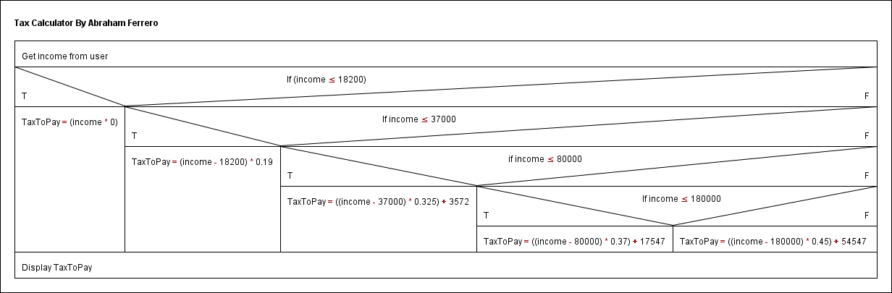
1.- N/S Chart.

2.- Test Plan

Salary | Expected | Result Test 1 | Result Test 2
0 | 0 | ✔ | ✔
1 | 0 | ✔ | ✔
5000 | 0 | ✔ | ✔
18200 | 0 | ✔ | ✔
18201 | 0.19 | ✔ | ✔
37000 | 3572 | ✔ | ✔
37001 | 3572.325 | ✔ | ✔
50000 | 7797 | ✔ | ✔
80000 | 17547 | ✔ | ✔
Salary | Expected | Result Test 1 | Result Test 2
80001 | 17547.37 | ✔ | ✔
150000 | 43447 | ✔ | ✔
180000 | 54547 | ✔ | ✔
180001 | 54547.45 | ✔ | ✔
-1 | "You must enter a positive value" | ✖ (result “0.0”) | ✔
aaa | "Taxable income must be a whole number" | ✔ | ✔
5.5 | "Taxable income must be a whole number" | ✔ | ✔

